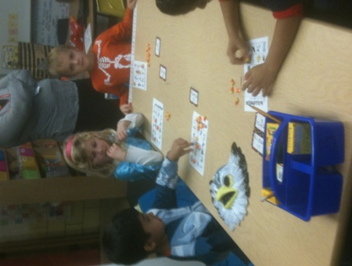
Reading: We will wrap up Theme 6: Meet My Family with a theme progress test. This week students will continue to work on creating images and will review use fix-up strategies. They will be introduced to the vocabulary words: describe, each, celebration.
Students will be exposed to realistic fiction, expository fiction, nursery rhymes, and reports.
This week the words that we are focusing on are: for, me. Remember to practice your sight words daily!
Writing: Students will be publishing their first report! They class will be writing a report together and it will come home Friday! Make sure to look for it in their folders!
Math: Students will finish chapter 4 this week. We will review one more and greater than. They will then learn about one less and fewer. Students will also learn to use one more and less to compare number values. They will finish up the week with an assessment on Chapter 4!
Cookie Sale: The high school Life Skills students will be selling cookies on Wednesday, Nov. 6th at Wilder Waite. If you would like your child to purchase a cookie to eat in class, please send money labeled for cookies.
Snack Time: Please encourage your child to bring a healthy snack each day to school.
Halloween Party: Thank you to everyone who helped and planned the Halloween Party! The kids loved it! Everyone had fun!
Things to Remember:
- Life Skills cookie sale—Wednesday, Nov. 6th
- Library books—due back Thursday, Nov. 7th
- Hearing and vision screening—Friday, Nov. 8th
- Brain Work folder – Due by Friday, Nov. 8th
- No School Veteran’s Day—Monday, Nov. 11th

