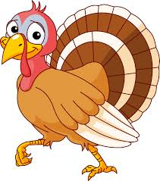
Reading: We will begin Theme 7: Does It Go Fast or Slow. This week students will work on synthesizing and will review creating images. They will be introduced to the vocabulary words: move, distance, speed.
Students will be exposed to expository fiction, humorous fiction, poems, and stories!
This week the words that we are focusing on are: do, big. Remember to practice your sight words daily!
Writing: Student will be writing a story using the drafting process. Prewriting, drafting, editing, rewriting, and publishing!
Math: Students will begin chapter 5 on size and position. They will be able to identify objects that are on top of, under, next to, behind, in front of, and inside other objects.
Snack Time: Please encourage your child to bring a healthy snack each day to school.
Library Books: Please know we do not check backpacks for your child’s library book. They are responsible to put the book into the basket when they get to school.
Turkey Feathers: Turkey feathers need to be decorated and sent back to school by Wednesday, Nov. 13th. Please feel free to decorate your feather with pictures, drawings, words, etc. that your student is thankful for.
Mystery Student: We have started to choose a mystery student everyday and watch their behavior throughout the day. If they followed all expectations they receive a certificate and a prize. The mystery student’s picture will be posted on our class website!
Things to Remember:
- Library books—due back Thursday, Nov. 14th
- Brain Work folder – Due by Friday, Nov. 15th
- School Board Meeting-- Wednesday, Nov. 20th at 7pm at Banner
- Hearing and vision re-screening—Friday, Nov. 22nd
- Fall Vacation—Wednesday, Nov. 27 thru Friday, Nov. 29th

