Now I’m In Kindergarten

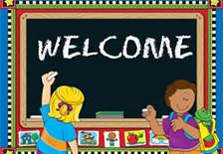

Dunlap Community Unit School District #323
Educate. Empower. Excel.

www.dunlapcusd.net

Dunlap Community Unit School District #323

Mission Statement

The Dunlap School Community will empower all students to excel in a global society.

Vision
Dunlap students will continuously excel in a global society by being:
      - Self-motivated learners
      - Critical thinkers
- Effective communicators
- Skilled collaborators
- Responsible and culturally aware citizens
- Technologically capable creators

Values and Beliefs
We believe that:
- While all children can learn, they learn at different rates and in different ways.
- High expectations and an engaging, innovative, technological learning environment are critical to the learning success of all students.
- Students must take responsibility for their own learning and achievement.
- Effective collaboration requires trust, mutual respect, open, and honest communication.
- District policies are necessary to ensure equitable and consistent implementation of expectations.
- Goals must be specific, measurable, attainable, results-oriented, and time-bound.
- Continual stakeholder feedback guides improvement.

Welcome To Kindergarten

It has been said that the type of beginning that a child has in school has a bearing on his or her entire life that follows. With this in mind, it is important that your child’s first school experiences be happy and enjoyable ones. With your cooperation, we can be assured of success.

This booklet is meant to provide you and your child with important information about our kindergarten program. You will learn:
- How you – the parent – can help your child succeed.
- School policies that will affect you and your child.
- What will be taught.
- Activities that will enhance the school experience.

It is important for your child to know that the lines of communication between home and school are always open, and that parents and teachers are working together to support the student.

Dr. Jay Marino

Superintendent

Banner Elementary School
Mr. Greg Fairchild, Principal
243-7774

Dunlap Grade School
Mrs. Mandy Ellis, Principal
243-7772

Hickory Grove Elementary School
Mr. Jeremy Etnyre, Principal

Ridgeview Elementary School
Mr. Todd Jefferson, Principal
692-8260

Wilder-Waite School
Mrs. Stacy Berg, Principal
243-7728

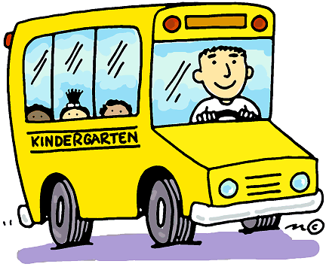

Getting Ready for School…

Parents are a child’s first teacher. You can help your child feel secure in school by your attitudes and reactions. The following list can be used as a guide in directing your child’s learning experiences at home.

- Teach your child to dress himself/herself and to button, zip and tie, to put on mittens/gloves and boots. Your child should be able to put on his/her own coat and shoes and fasten them. If your child has difficulty tying shoes, there are many shoe options without laces that will help your child be independent.
- Read books to your child and encourage him/her to retell the stories in sequence.
- Help your child feel important. You can do this by showing a sincere interest in the things your child brings home from school.
- Teach common courtesies, such as listening when others speak and by saying “please”, “thank you” and “excuse me.”
- Encourage your child to perform simple tasks at home. When tasks have been accomplished, praise your child.
- Listen to your child when he speaks to you. Always encourage him/her to speak distinctly and in complete sentences.
- Provide experiences that help the child establish sensitivity toward all living things, a concern for others and the ability to get along with others.
- Help him/her with large muscle development: hopping, skipping, climbing, sliding and stair climbing. Help him/her with small muscle development: cutting, gluing and finger play.
- Provide many learning opportunities. For example, use road signs for number and letter identification; a downtown shopping trip for help with colors; a rainy afternoon for drawing shapes; counting the silverware as it is put around the table and a game of picking words that start or end the same.
- Good conduct originates in the home. It is the obligation of parents, through their teaching and by their example, to help their child develop attitudes of respect for himself/herself, for the school, for the teachers and staff and for other children.

Supplies for Home

- Pencils, crayons and markers
- Scissors and glue
- Paper – lined and unlined
- Number and letter flash cards
- Manipulatives – coins, cubes, paperclips, buttons, dry cereal
- Bowls, paper plates for sorting and grouping

Kindergarten Readiness

Upon entering Kindergarten your child should be able to:
Fine Motor
- Hold scissors correctly
- Hold pencil or crayon properly
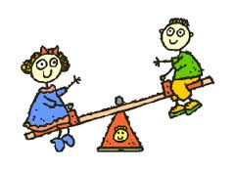
Gross Motor
- Run, jump, skip
- Walk backwards
- Walk up and down stairs
Social Skills
- Use words to communicate needs
- Pay attention for short periods of time to adult-directed tasks
- Follow simple directions
- Button, snap, zip and fasten own clothing and shoes
- Use bathroom independently
- Wait his/her turn and shares
- Talk in complete sentence of five to six words
- Tell a story about a past event
- Say “please” and “thank you”
Personal Info
- Know his/her full name
- Know how old he/she is
Academic Skills
- Recognize shapes (square, triangle, circle and rectangle)
- Sort items by color, size and shape
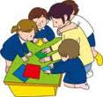
- Identify six parts of his/her body
- Count from one to ten
- Recognize eight basic colors
- Write his/her first name
- Recognize his/her first name in print

Daily Schedule (Sample)
7:45-7:50 Unpack
7:50-8:05 Calendar
8:05-8:15 Phonemic Awareness
8:15-8:35 Phonics Instruction
8:35-9:00 Math (direct instruction)
9:00-9:10 Bathroom Break, Decodable Books
9:10-9:30 Recess
9:30-9:40 Handwriting Practice
9:40-10:10 Language Arts (direct instruction)
10:10-10:30 Shared Writing and Reading Activities
10:30-10:45 Pack up and dismissal of half day students
10:30-11:00 Independent work folders, story
11:00-11:45 Lunch, Recess, Bathroom Break
11:45-12:00 Quiet Reading
12:00-12:30 Science, Unit Activities
12:30-1:00 Language Centers, Guided Reading
1:00-1:30 Special – Music, Art, Technology or PE
1:30-2:00 Bathroom Break, Snack, Recess
2:00-2:25 Differentiation, Math Centers
2:25-2:45 Pack Up, Daily Review, Dismissal

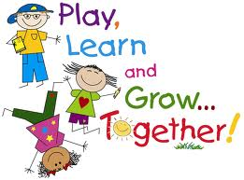

How to Help Your Child Succeed in Kindergarten

Studies show that children who attend school regularly have greater academic, social and personal success! Children who do not attend school regularly often struggle to succeed in reading and math, key elements to future education.

- Eat a good breakfast every morning.
- Establish a morning routine. Get up in time to prepare for school without rushing.
- Have a backpack to carry things back and forth to school.
- Get to know your child’s teacher and their expectations.
- Be encouraging: Talk about school and learning in a positive way.
- Be consistent: Establish a homework routine.
- Be a good role model – read when your child reads, write notes or letters, ask questions, provide details.
- Stay interested in your child’s work and progress.

All I Ever Really Needed to Know I Learned in Kindergarten

By
Robert Fulghum

Most of what I really need to know about how to live, and what to do, and how to be, I learned in kindergarten. Wisdom was not at the top of the graduate school mountain, but there in the sandbox at nursery school.

These are the things I learned. Share everything. Play fair. Don’t hit people. Put things back where you found them. Clean up your own mess. Don’t take things that aren’t yours. Say you’re sorry when you hurt somebody. Wash your hands before you eat. Flush. Warm cookies and cold milk are good for you. Live a balanced life; learn some and think some and draw and paint and sing and dance and play and work every day some.

Take a nap every afternoon. When you go out into the world, watch for traffic, hold hands and stick together. Be aware of wonder. Remember the little seed in the plastic cup. The roots go down and the plant goes up and nobody really knows how or why. But we are all like that.

Gold fish and hamsters and white mice and even the little seed in the plastic cup – they all die. So do we.

And then remember the book about Dick and Jane and the first word you learned, the biggest word of all: LOOK. Everything you need to know is there somewhere. The Golden Rule and Love and basic sanitation. Ecology and politics and sane living.

Think of what a better world it would be if we all – the whole world – had cookies and milk about 3 o’clock every afternoon and then lay down with our blankets for a nap. Or if we had a basic policy in our nation and other nations to always put things back where we found them and cleaned up our own messes. And it is still true, no matter how old you are, when you go out into the world, it is best to hold hands and stick together.

